**CUSTOM BOOTCAMP**

**Power BI**

**Power BI­­­­­**

* It is one of the most popular Data Visualization and Business Intelligence tool.
* It is the collection of apps, connectors, and software services which are used to get the data from different data sources, transforms data and powerful useful reports.

**Power BI Tools**

* Power Query
* Power View
* Power Map
* Power Pivot

**Note:** 37 default visualizations are available in Power Bi.

**Available data sources in Power BI**

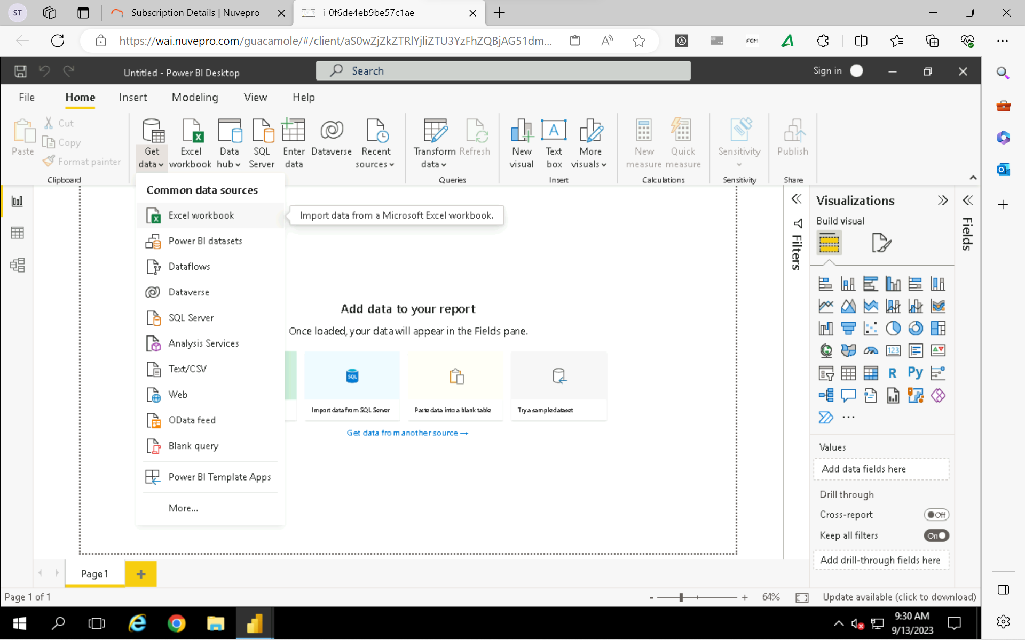

**Power BI Tabs**

* Report Tab
* Data Tab
* Model Tab

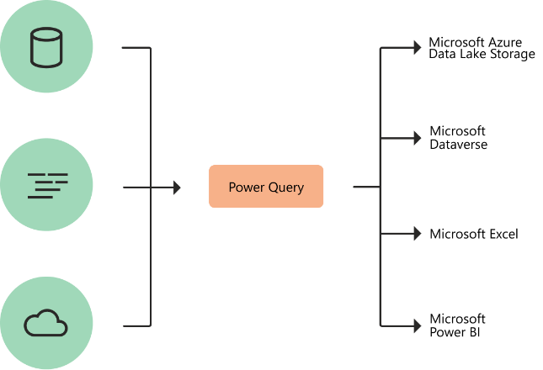**Power Query**

* It is a Data Transformation and Data Preparation tool within Microsoft Excel and Power BI
* It streamlines the process of importing data from variety of file types including Excel tables, CSV files, Database tables, Webpages, and so on, and allows you to transform your data into the proper shape and condition for better analysis.
* Power Query editor uses “M” programming language.

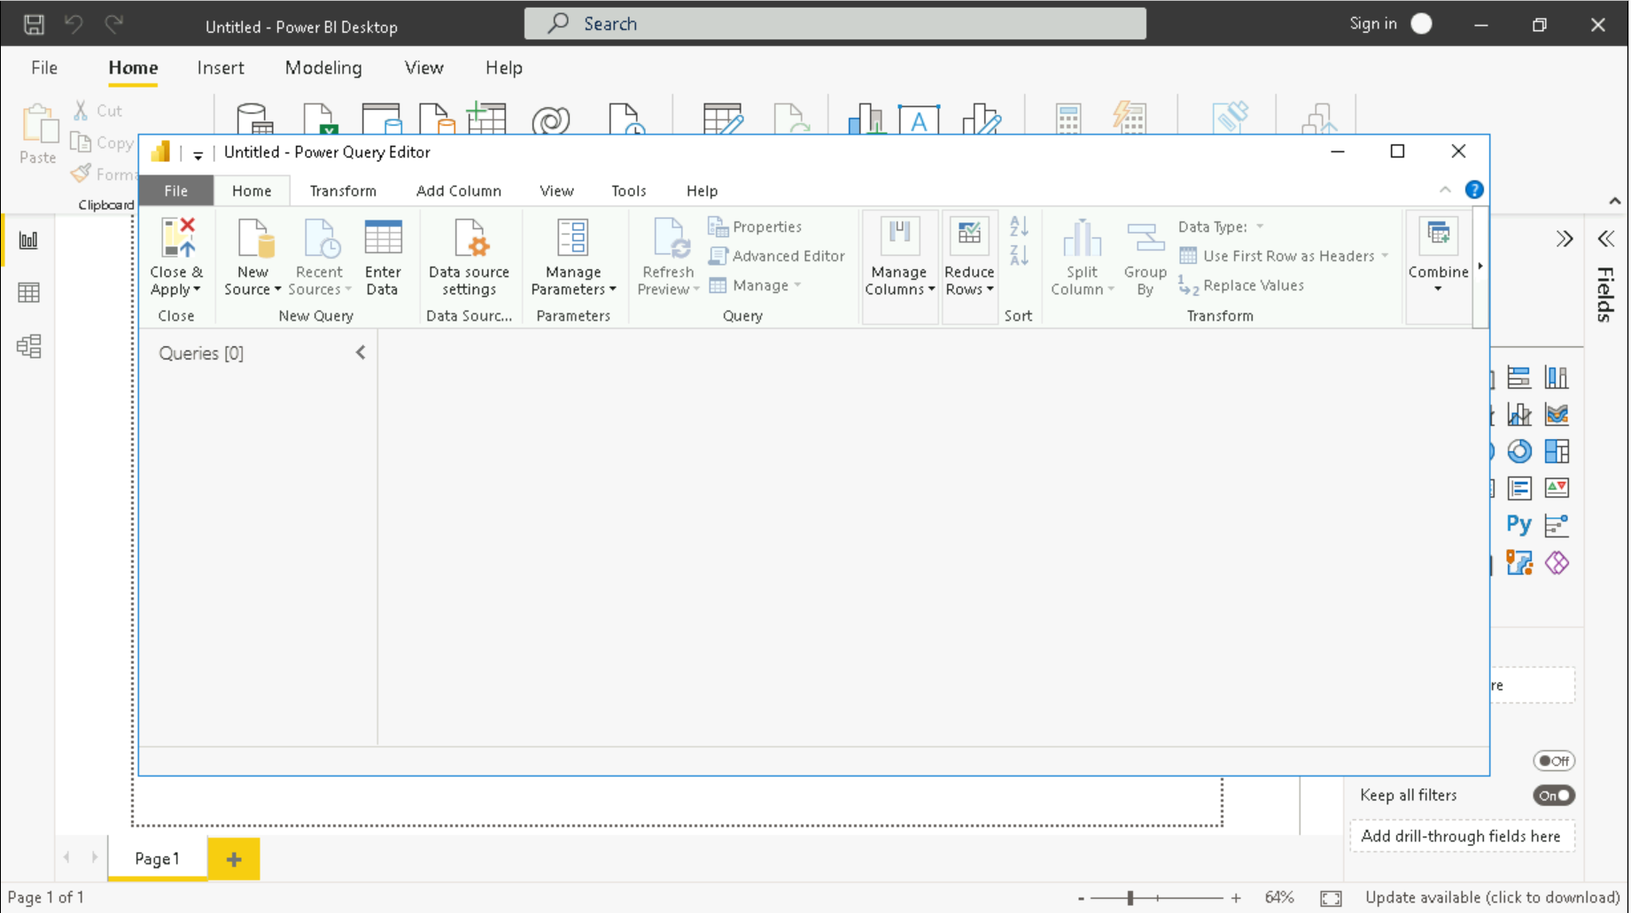

**Data Analysis Expression (DAX)**

**Connecting to MS SQL Server**

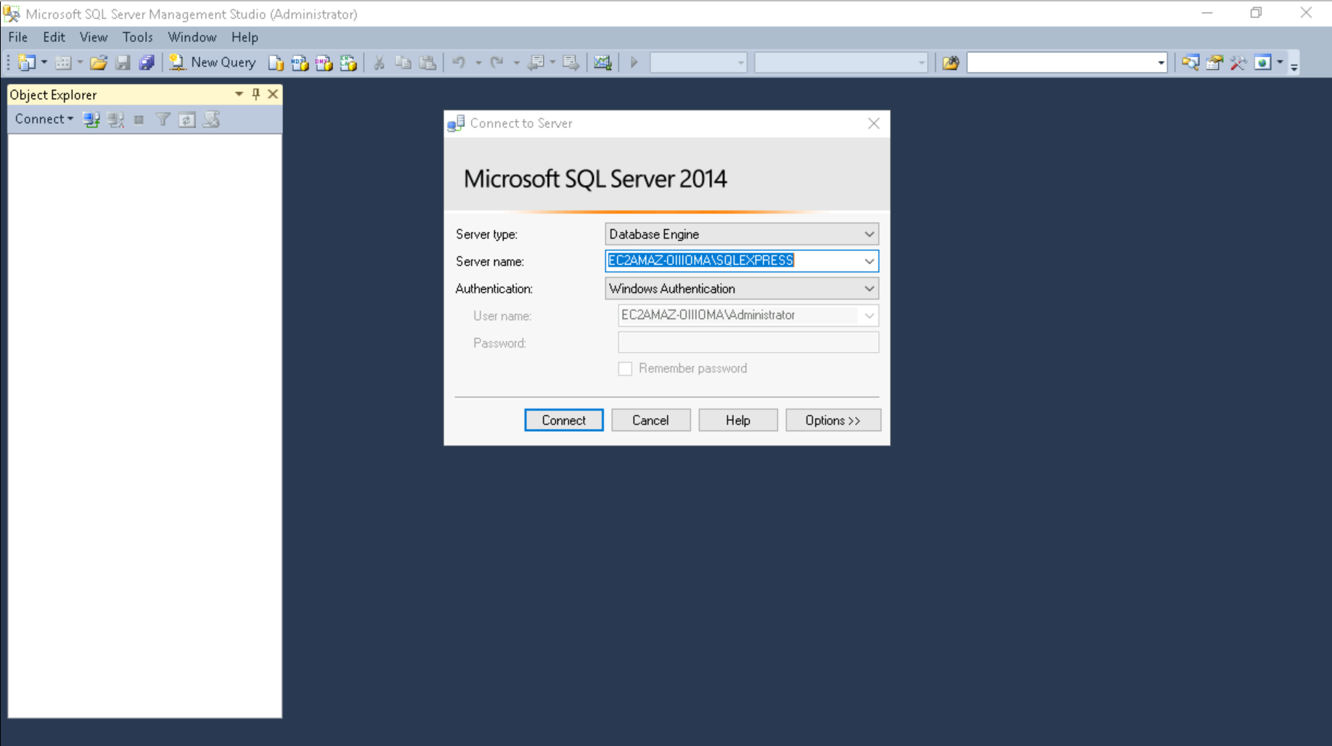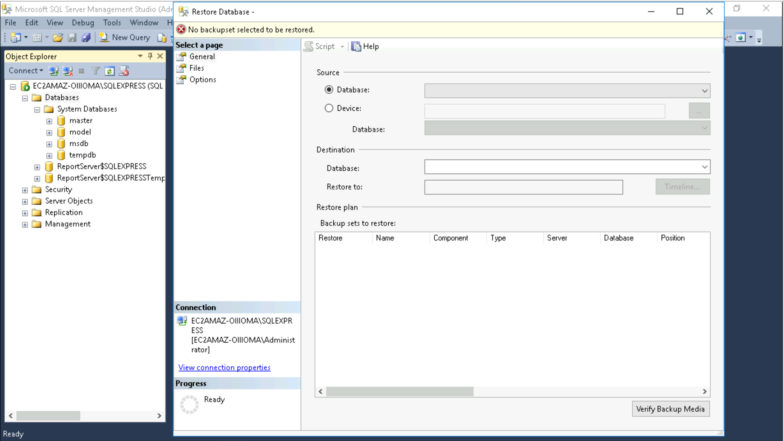

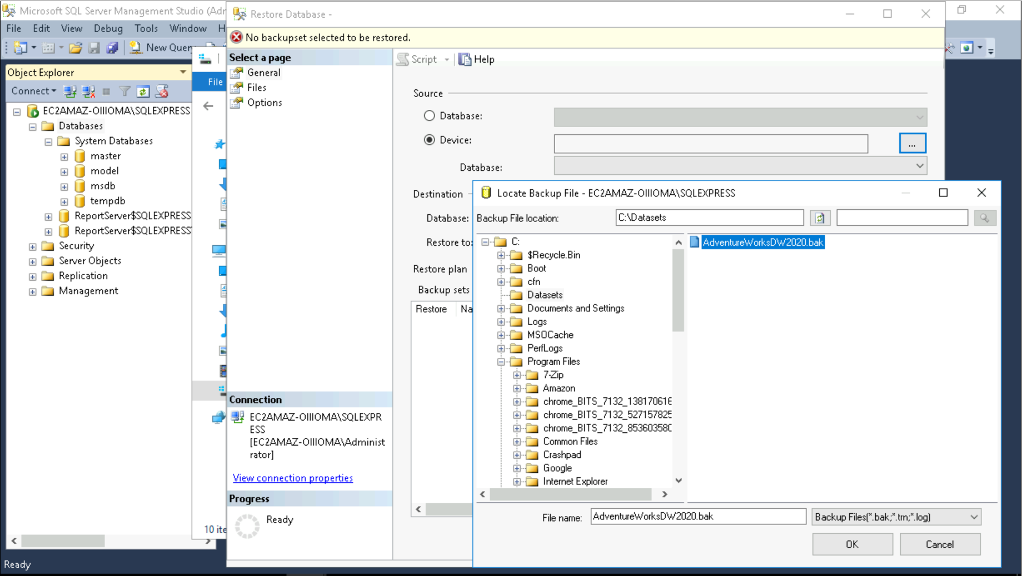

**Connecting SQL Server DB to Power BI using Import Connectivity Mode**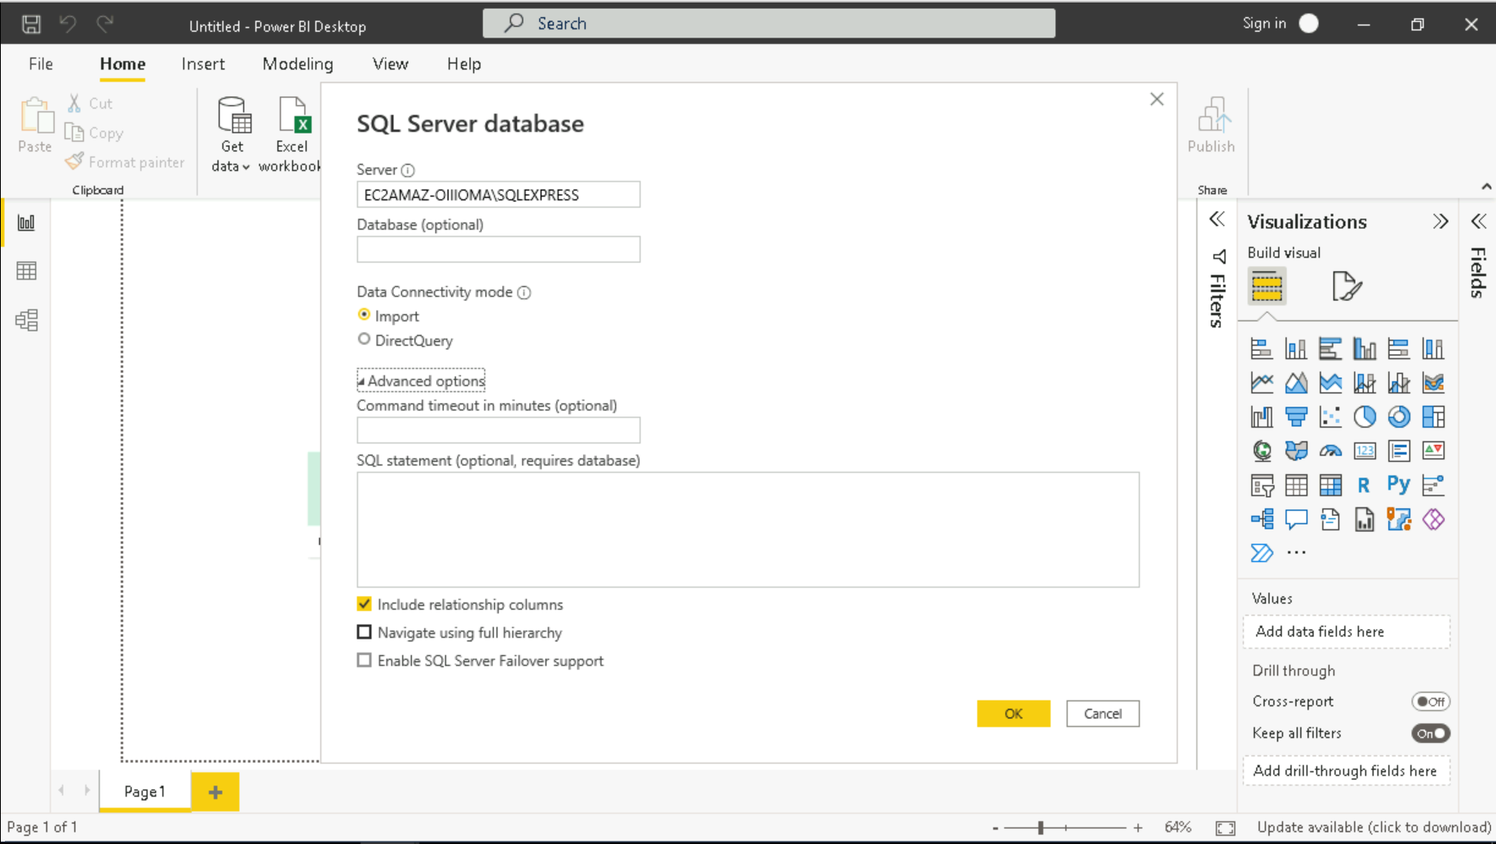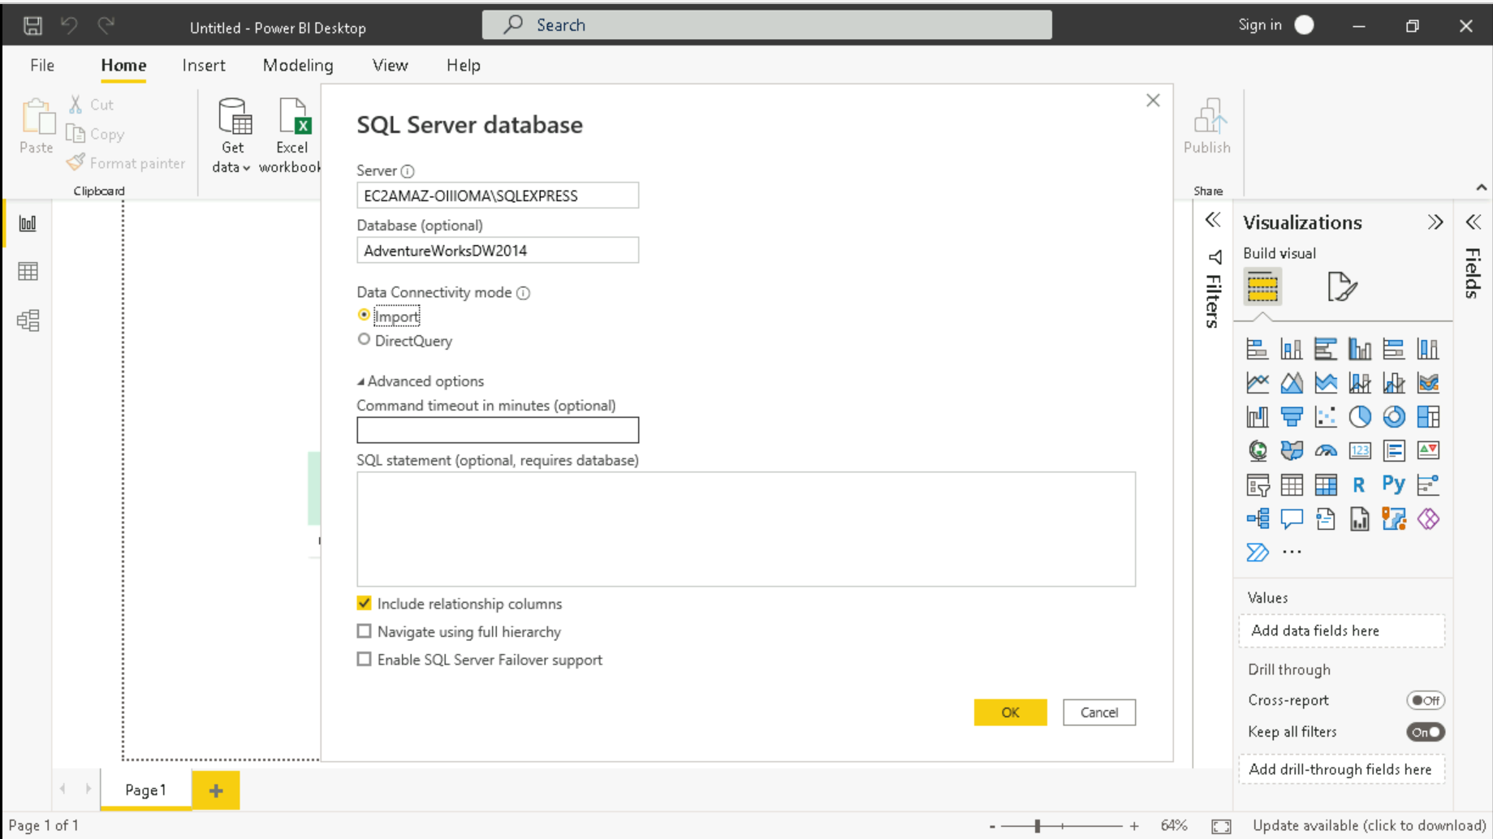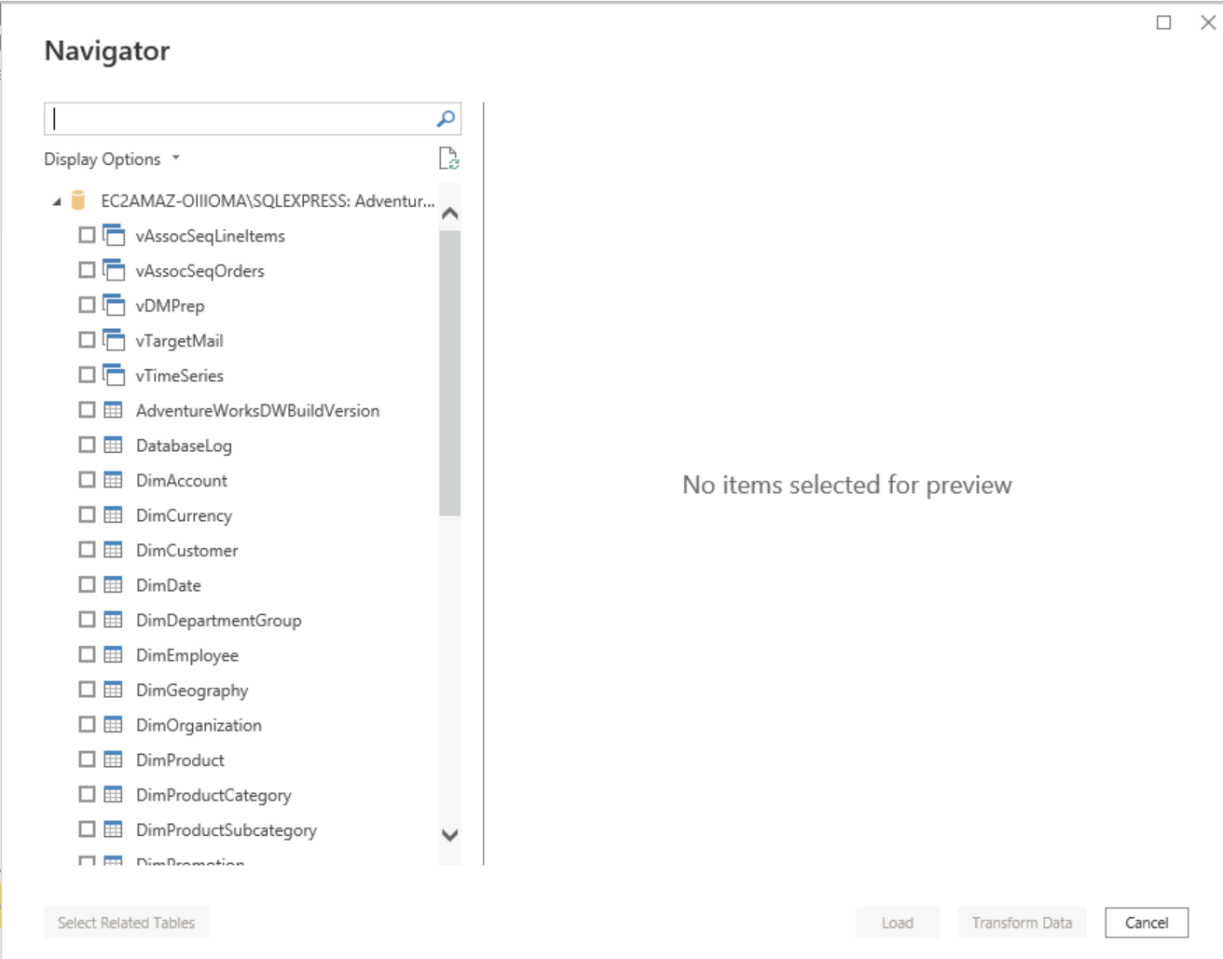

**Data Tab**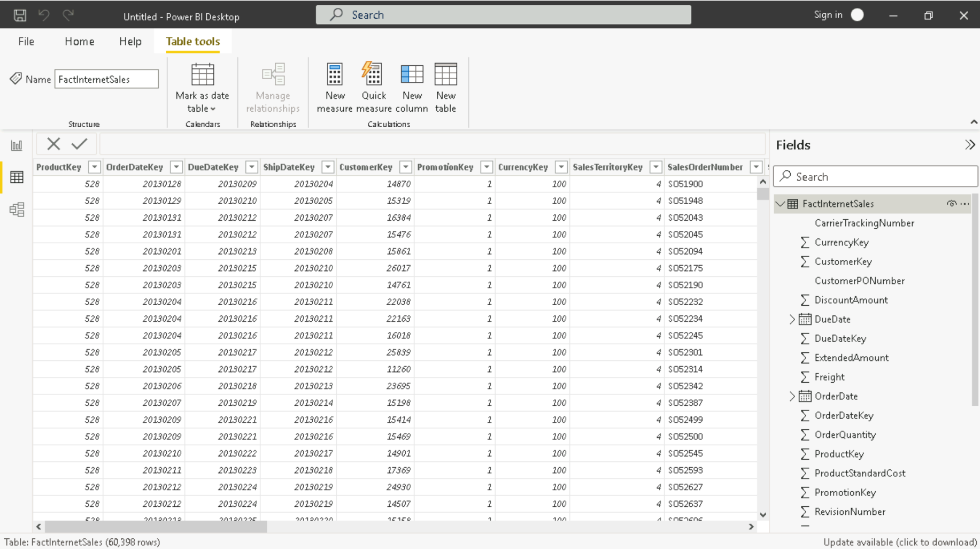

**Model Tab** 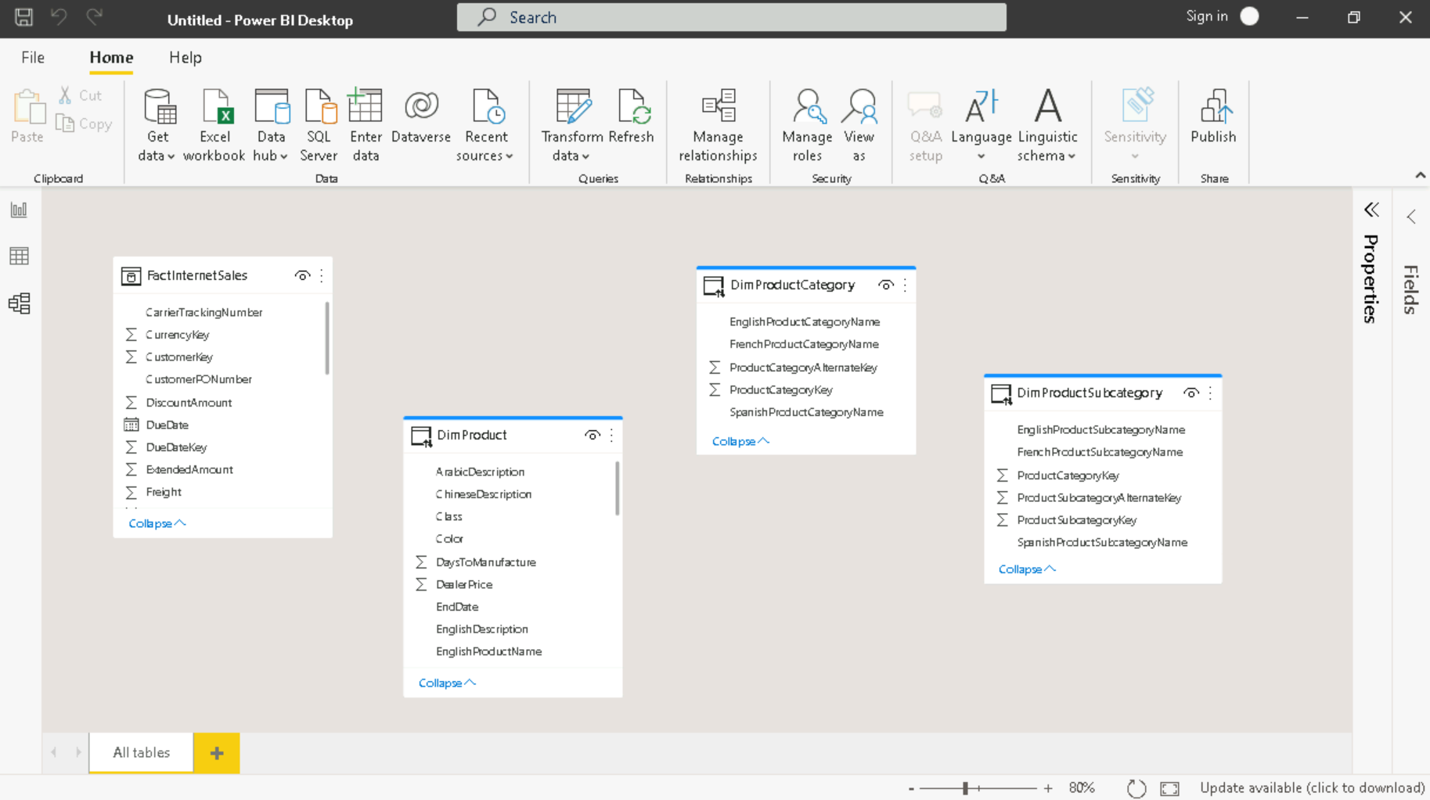

**Managing Relationships**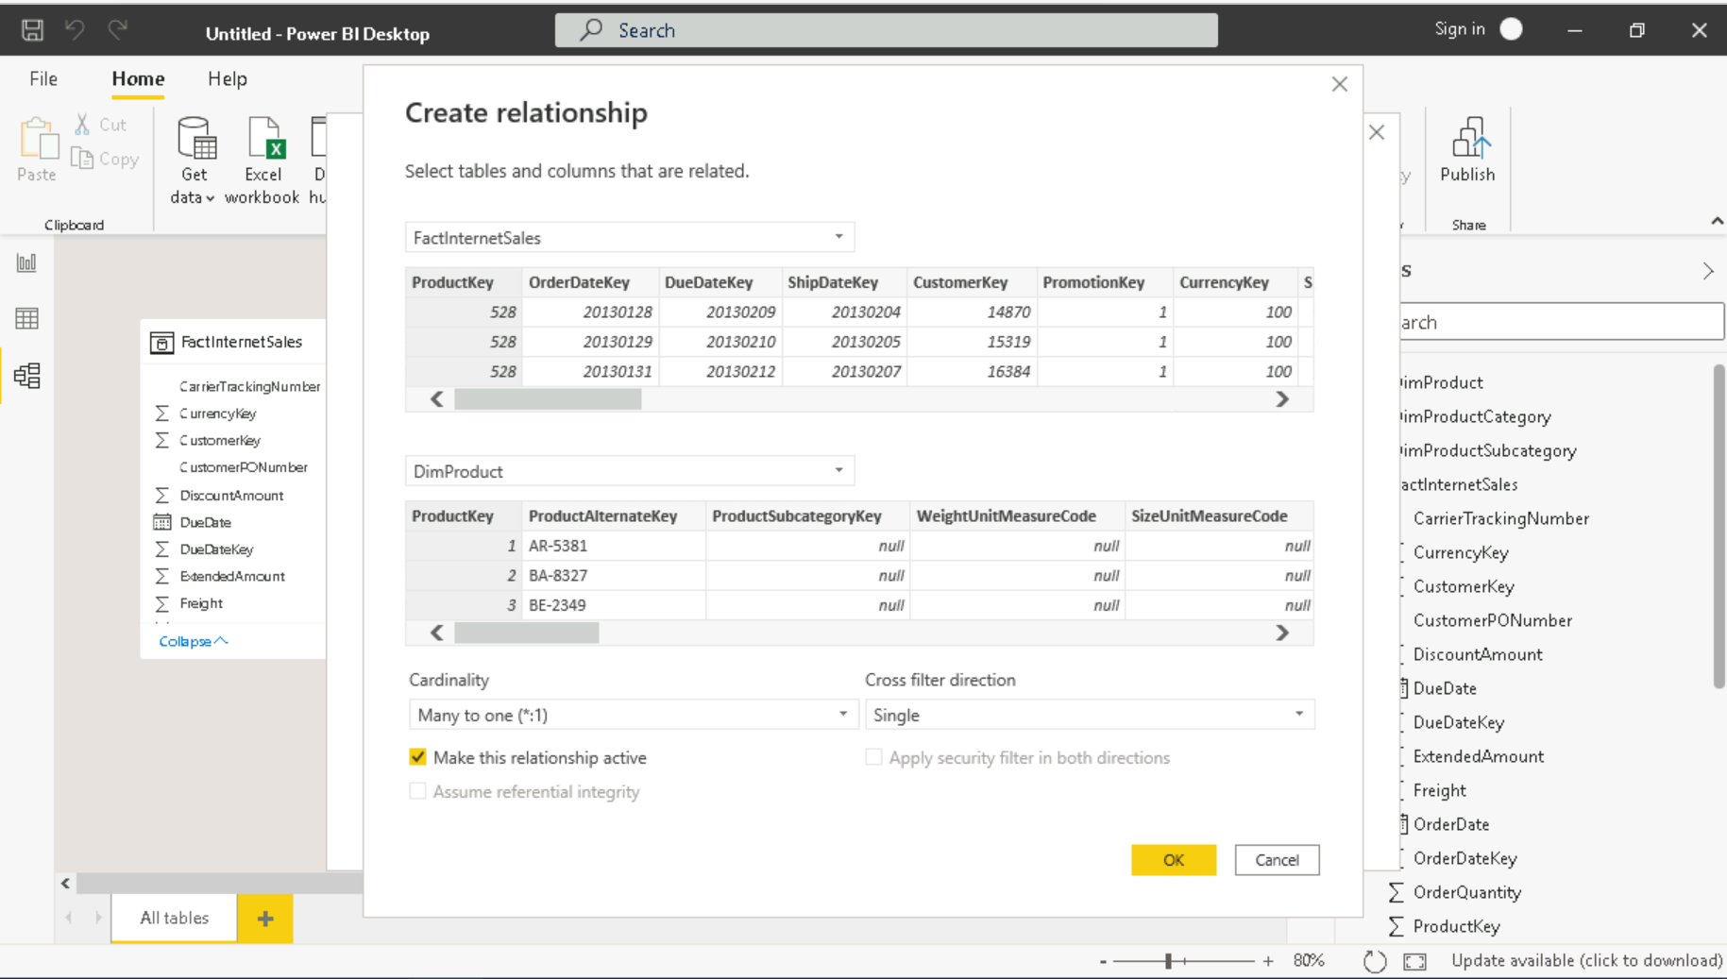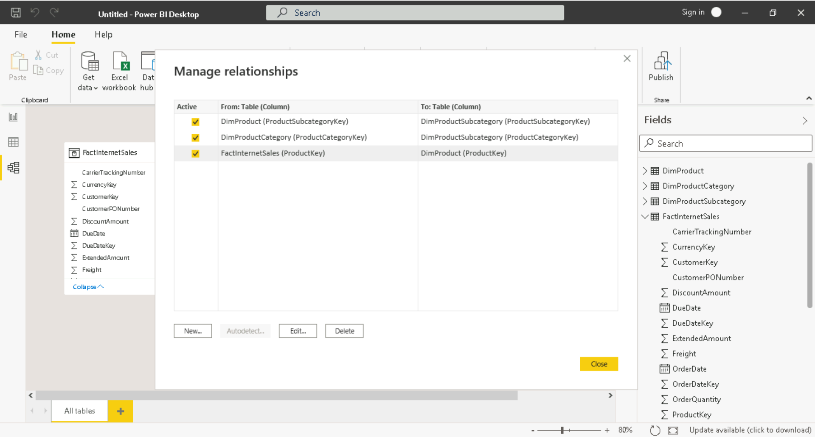

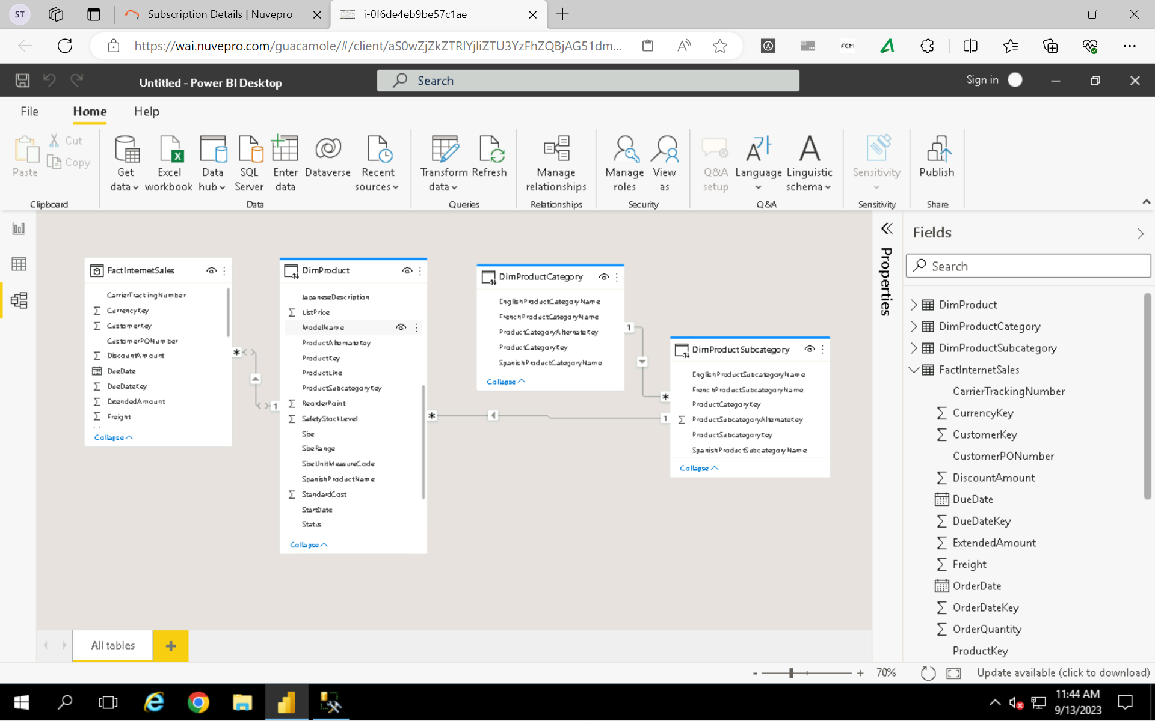

**Power Query Editor**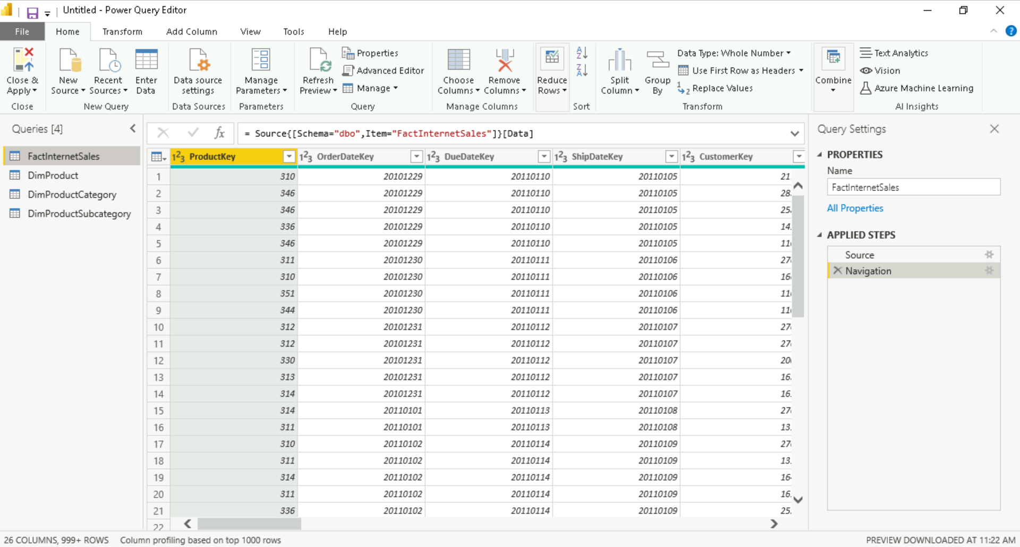

**Merging Tables**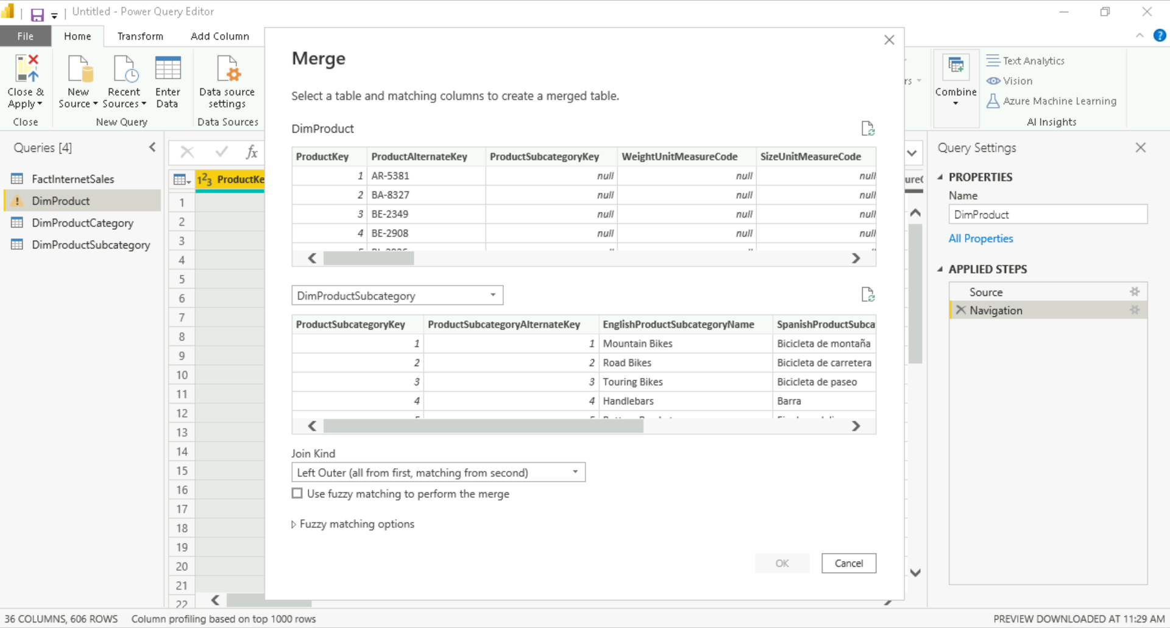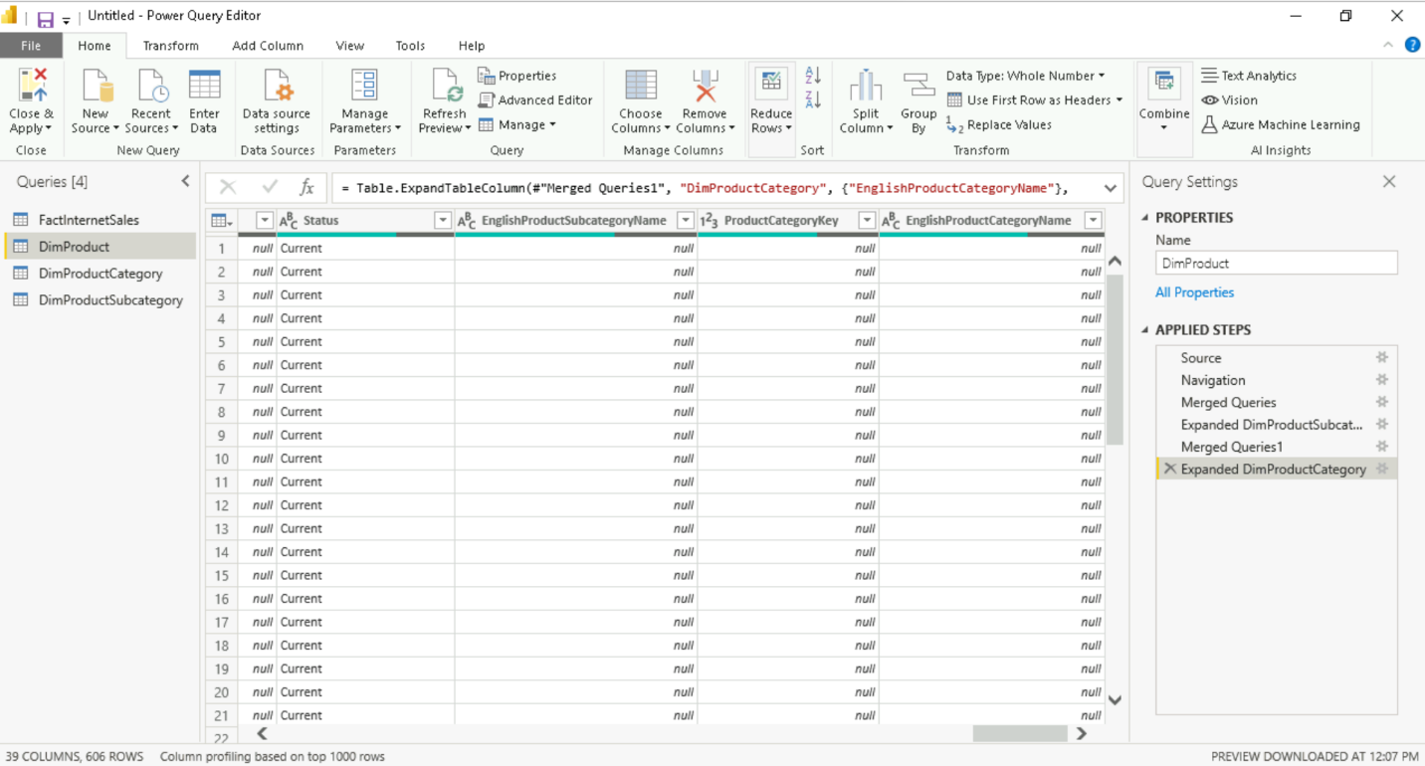

**Creating Power BI Notebook From Scratch With Different Datasets**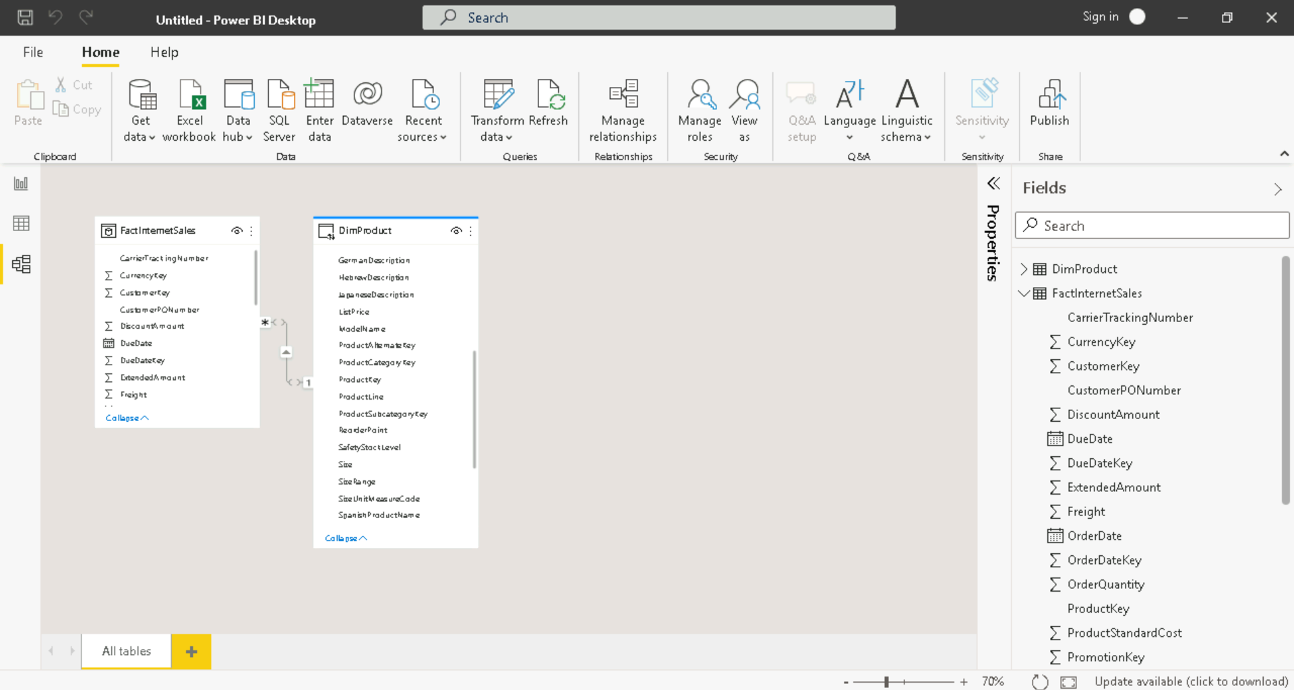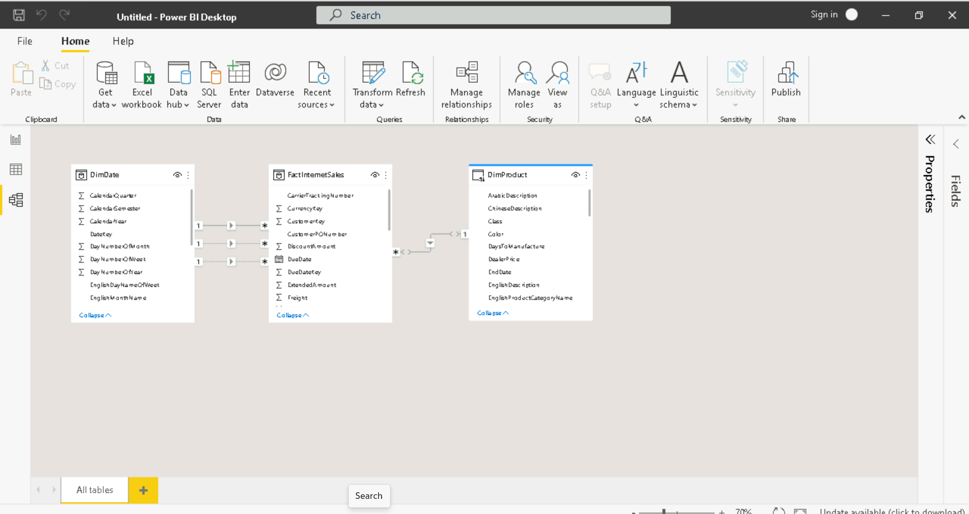

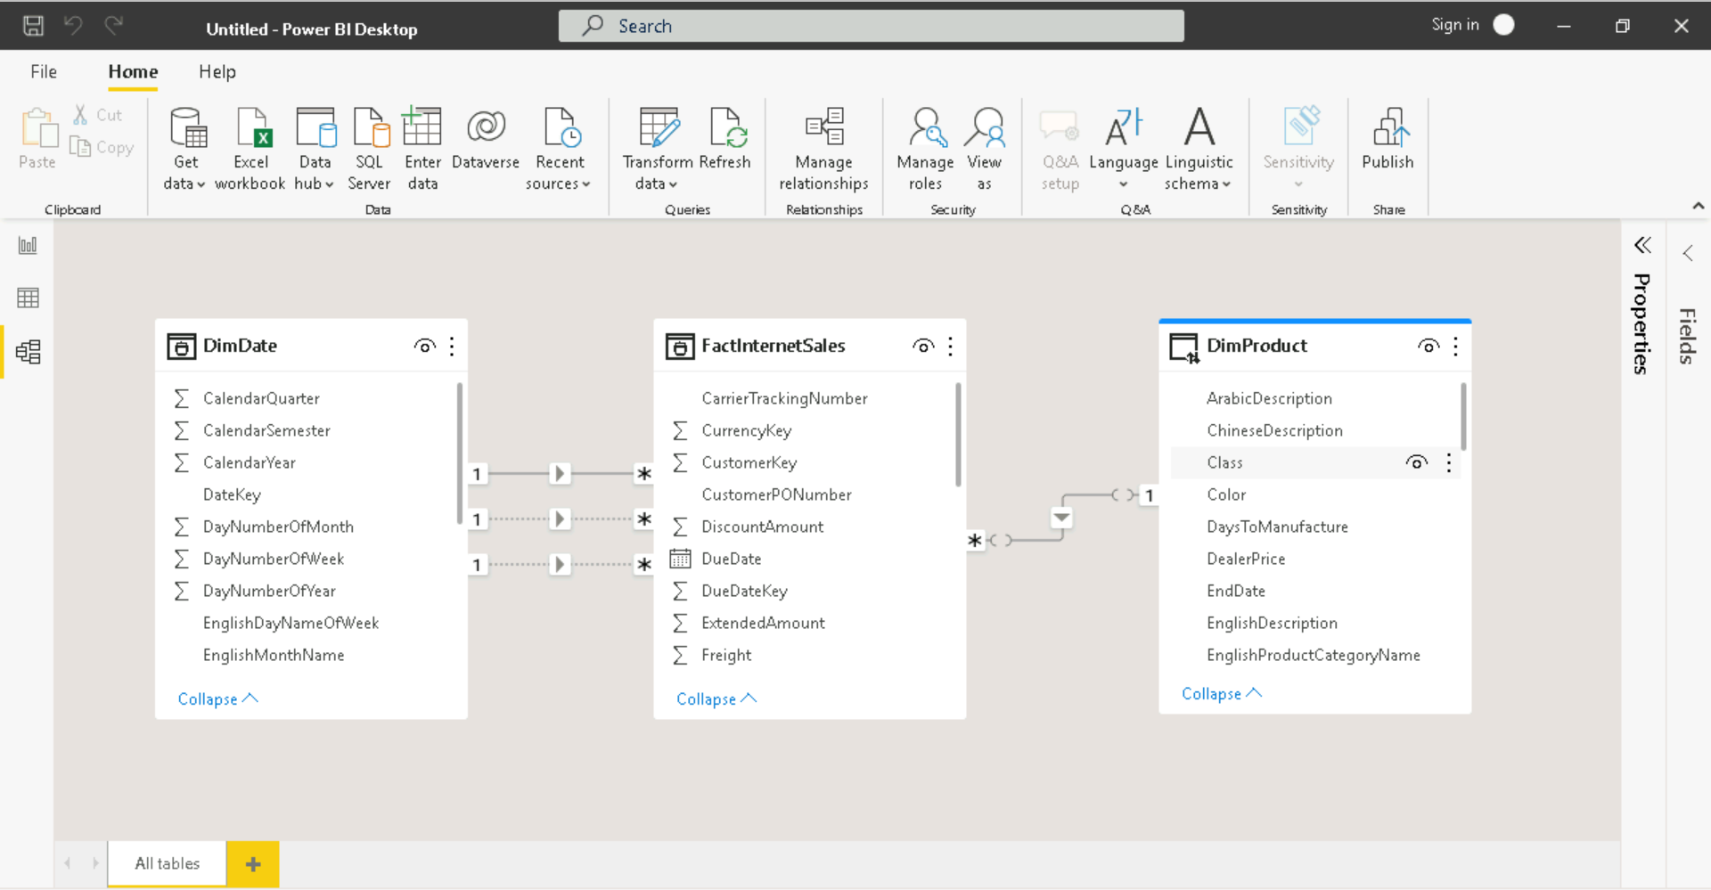

**Making Visualizations (Bar Chart)**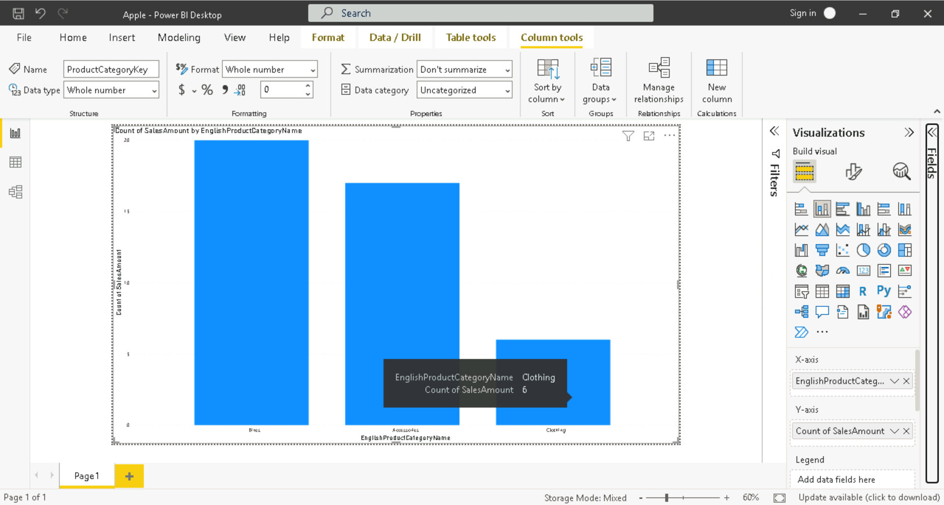

**Creating Power BI Notebook from Scratch With Different Datasets** 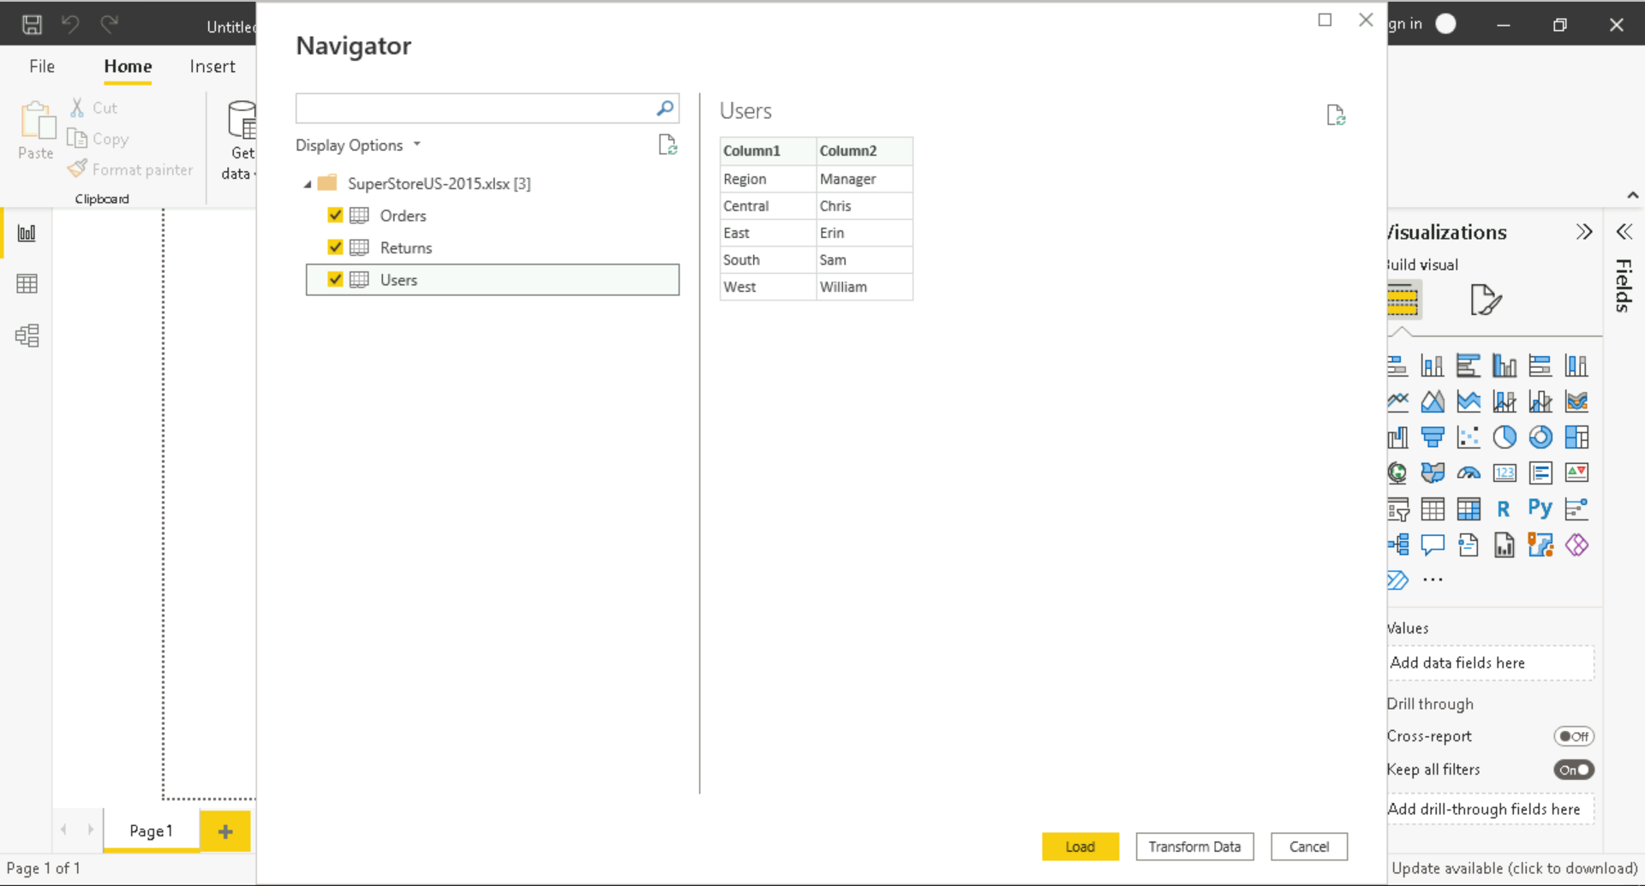

**Promoting Headers**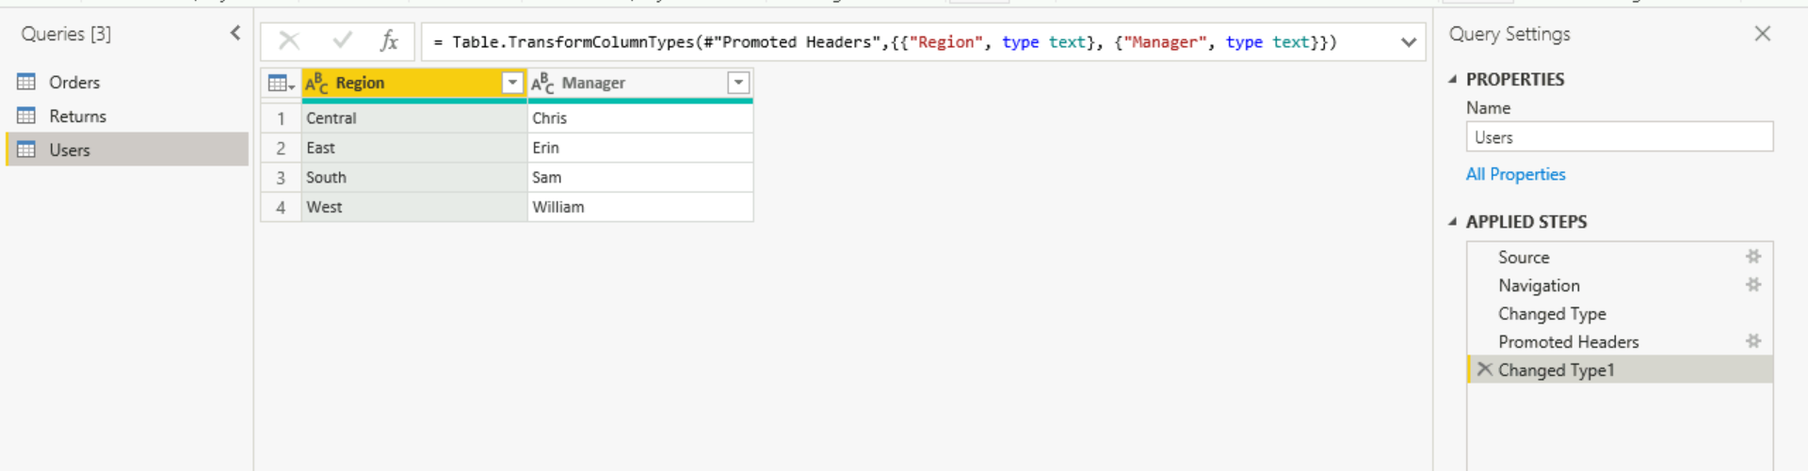

**Manage Relationships**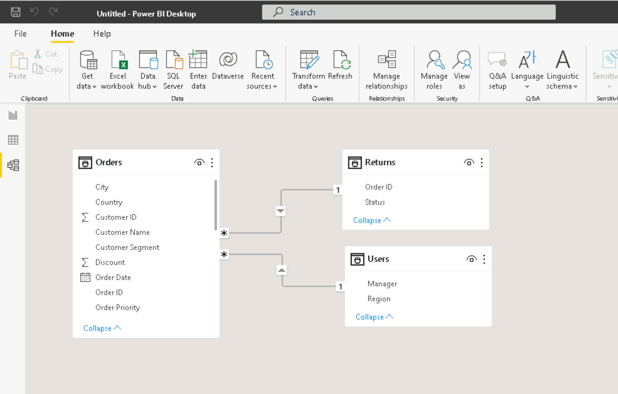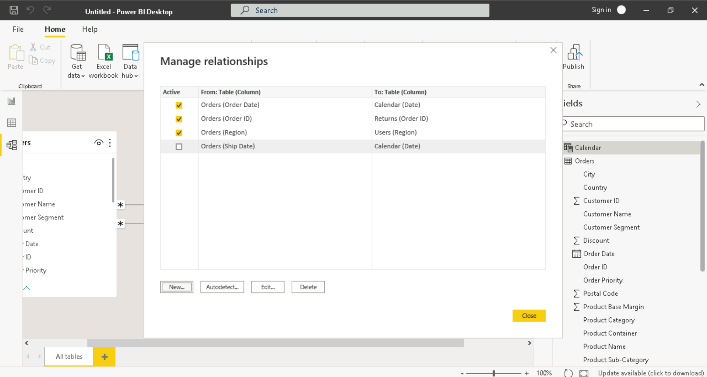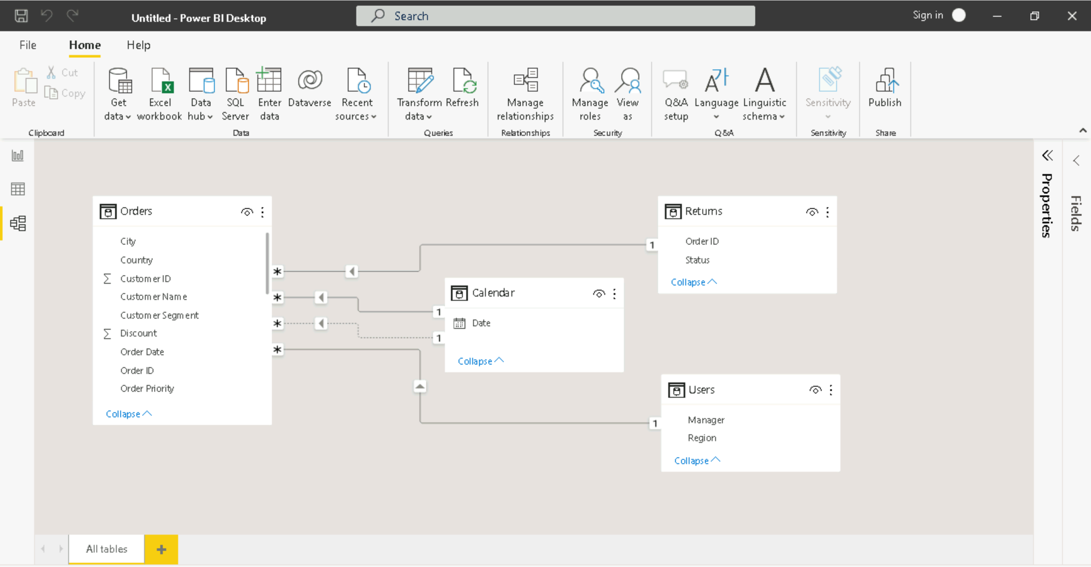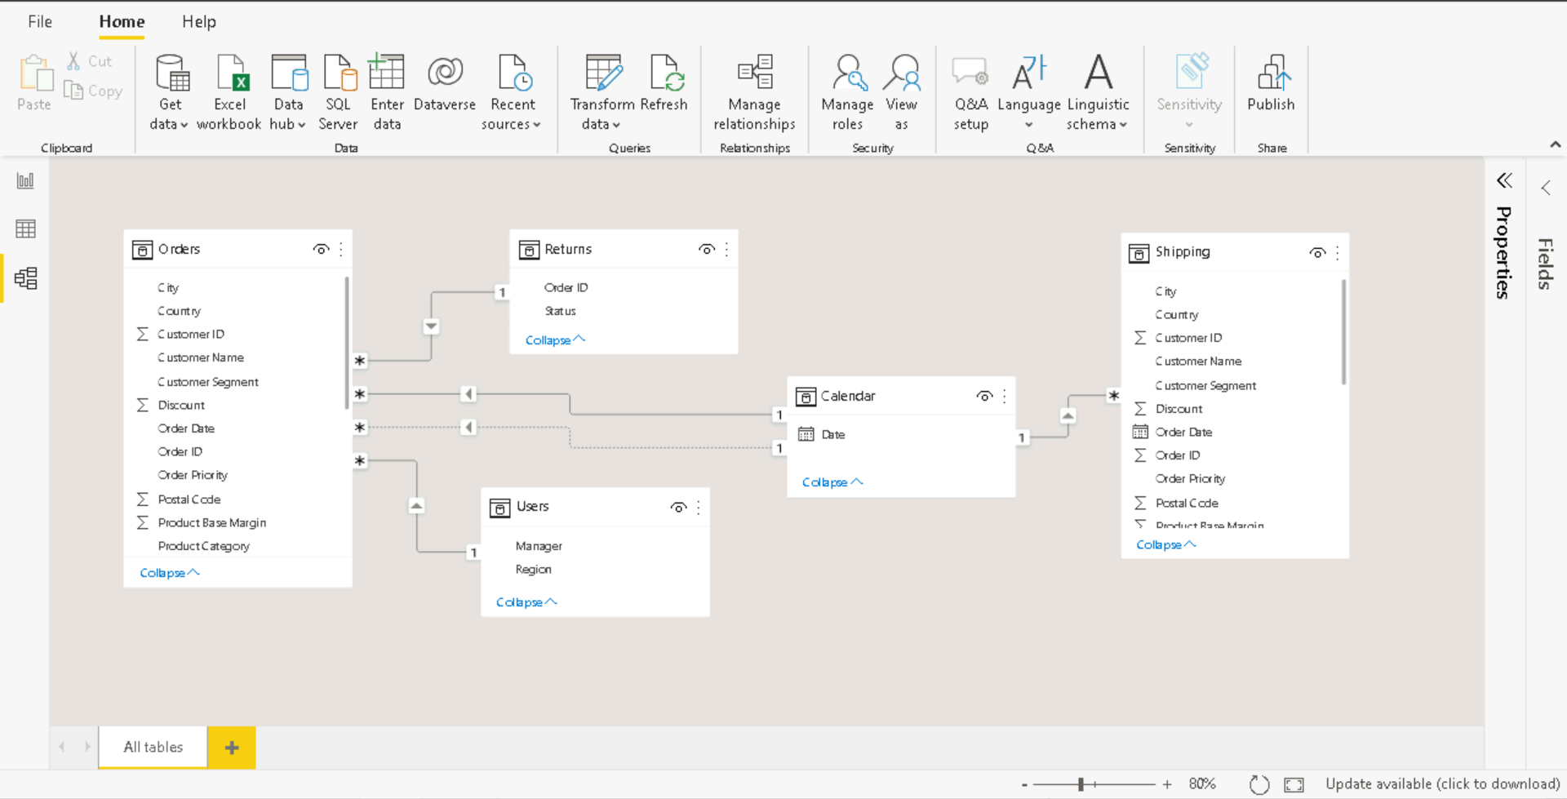

**Calculated Column**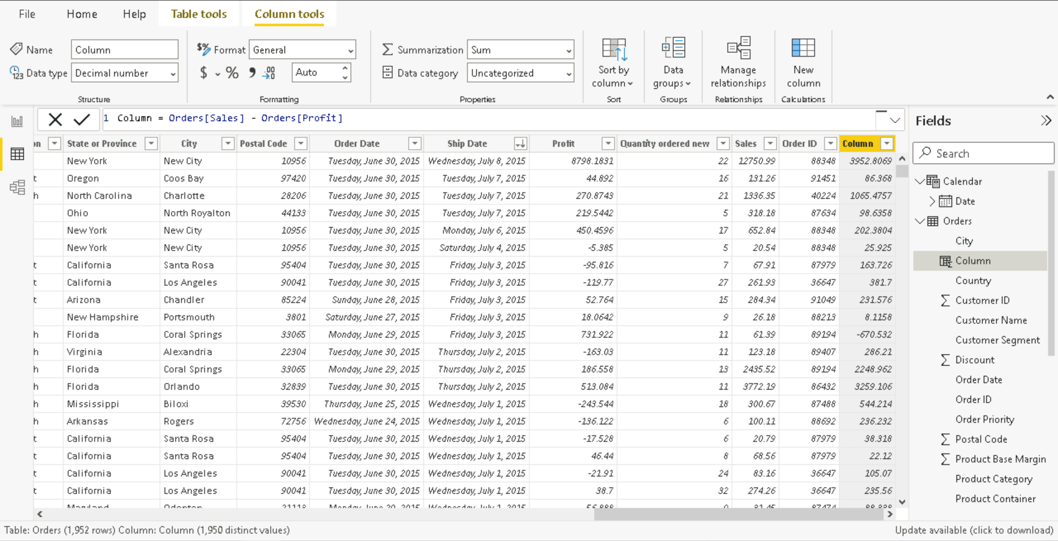

**Creating Customized Tables**